~Asia-China-Mirror-Warring States-(475-221 BCE)-Arc 16-Inscription 22 Characters

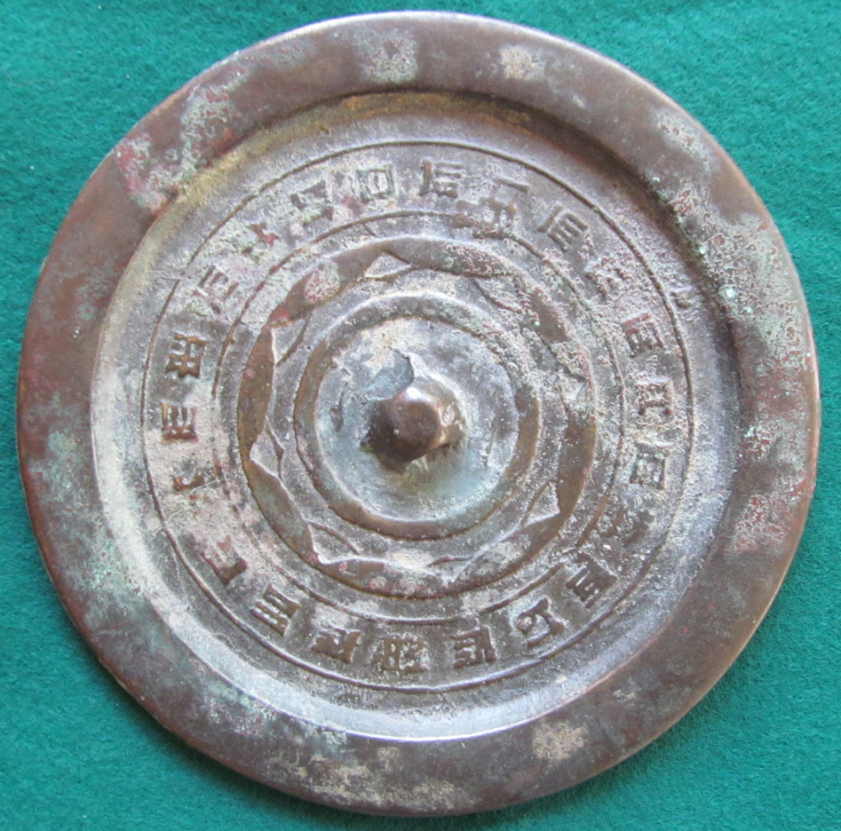

This Warring States (475-221 BCE) continuous arc mirror has eight continuous arcs conjoined with a separate non-continuous arc making a total of 16 arcs. It has a 22 character inscription.